Testing all Issues

https://github.com/InpharmD/inpharmd/issues/1633
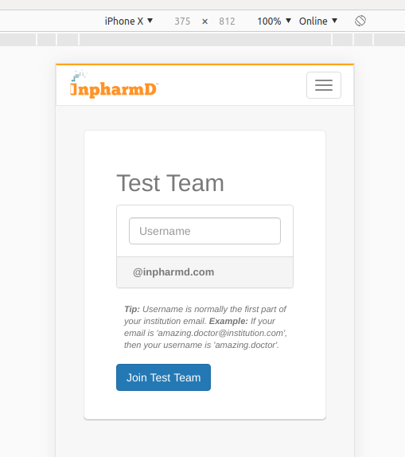

At present everything is looks good. Hear we didn't provided the logo. Better to test on staging.

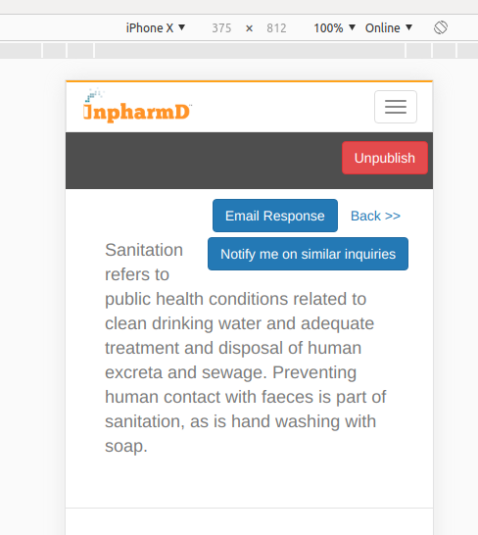
https://github.com/InpharmD/inpharmd/issues/1812

https://github.com/InpharmD/inpharmd/issues/1283
https://github.com/InpharmD/inpharmd/issues/1425
https://github.com/InpharmD/inpharmd/issues/1502
https://github.com/InpharmD/inpharmd/issues/1503

https://github.com/InpharmD/
notification of similar questions.......

Button alignment...

Border Missing.

Rating Alignment....missing

https://github.com/InpharmD/

logo displaying good...

https://github.com/InpharmD/

keep Users in place of Providers ....

https://github.com/InpharmD/

Mail and Heart box alignment missing....

https://github.com/InpharmD/

Mail box alignment missing...

And the popup was kept away on clicking on the favorite button, it worked good.

